Kurt Jensen

kjj

CS1350

Project 3

kjj.prog3

12/4/2020

CS1350 Programming Project 3 - BST Fall 2020 Due November 20, 2020 Mansfield, J

Design, test, implement and test a C++ program (using classes) that uses a linked list to create a Binary Search Tree of integers.

You will have an insert function along with the three traversals: inorder, preorder, postorder.

You should plan this program well. Include in your planning your testing methods for each required function – on both implementations.

Make sure to include all of your documentation for: a) planning; b) test and evaluation design; c) reflection.

Turn in all required documentation, to appropriate location on blackboard, one PDF called xyz.prog3.pdf:

• Cover page

• Copy of assignment

• Design documents – including all uml diagrams; testing design and any additional algorithms

• Reflection

Additionally, drop tarred and/or gzipped file in appropriate location on blackboard, the compressed file needs to be xyz.prog3.mmm where mmm is the extension your compression program assigns. NOTE: uncompressed folder MUST be xya.prog3

Due Date: 11/20/20

A binary search tree is a special implementation of a binary tree in which the first element inserted becomes the root, each subsequent element is compared to the root and inserted to the left if the element is less than the root, or right if the element is greater that the root.

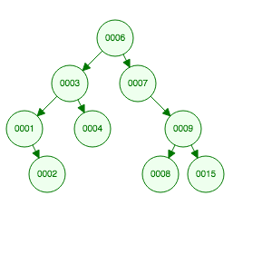

Algorithm:

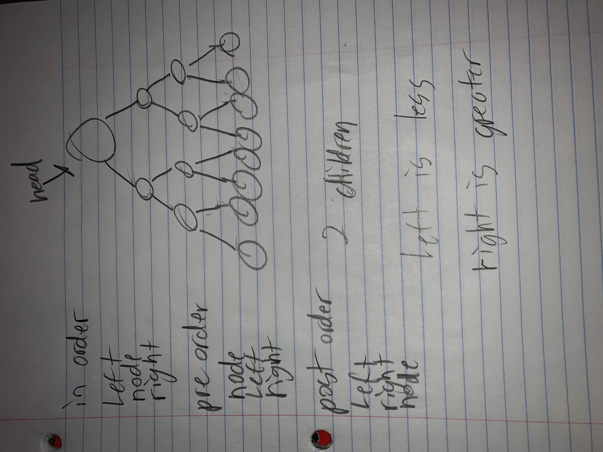

**Reflection:**

**Project Summary:**

I am slowly but surely getting better at linked lists. I had a better time understanding this project versus the others. This project was also easier because I had a very good understanding of how binary search tree work.

**Challenges:**

The challenges I found were again using linked lists. I still am not the greatest at linked lists, but I am getting better. I also found it hard when it was outputting. To me it looked it wrong, but when I looked up an example to matched mine when I inputted the same numbers.

**Solutions (Mitigation):**

The lessons I learned is understanding linked lists more then previously. I also learned how to implement a binary search tree into code rather than just knowing the concept.